Image Processing Assignment 2

Tareq Kirresh 1142828

Code Snippet Used:

**pkg load image;**

**x = imread("Pepper.jpg");**

**h = [1 0 0 0; 0 1 0 0 ; 0 0 1 0; 0 0 0 1];**

**y = imfilter(x,h);**

**imshow(y)**

**imwrite(y,"Pepper-Filter-1.jpg");**

**j = [-1 -1 0; -1 0 1; 0 1 1];**

**z = imfilter(x,j);**

**imshow(z)**

**imwrite(z,"Pepper-Filter-2.jpg");**

**Task 1 : Filter 1**

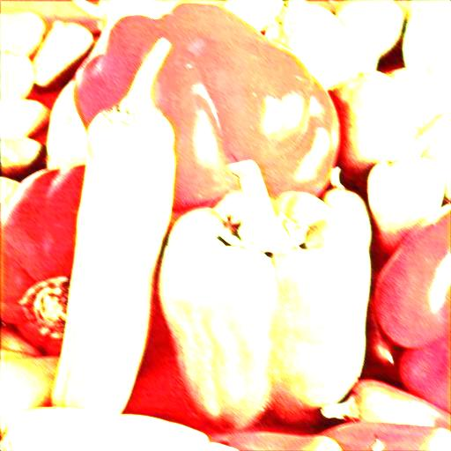

**Task 2 : Filter 2**

